To Change Quotes To A Valid Order In EIP

Click the customer link on your page, then click on ALL OPEN QUOTES
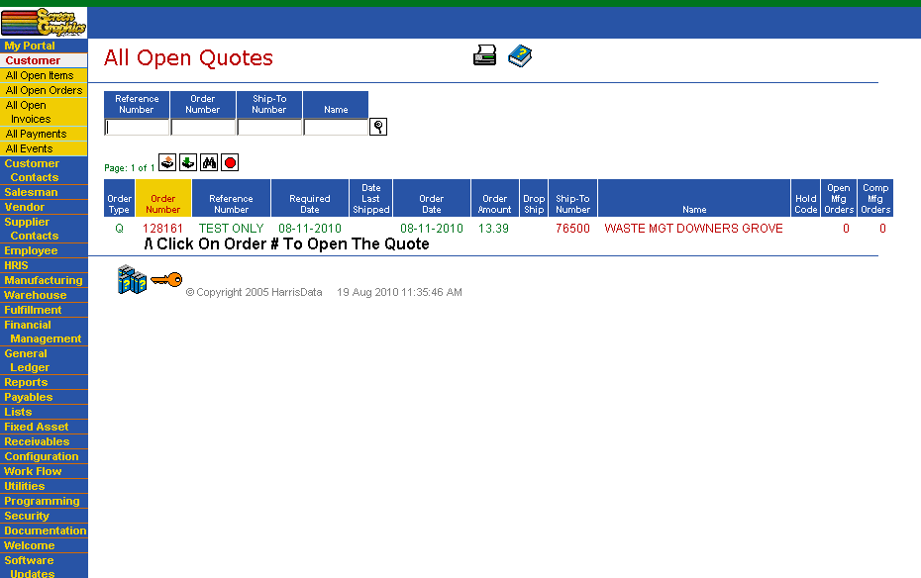

Click the icon to COPY RECORD
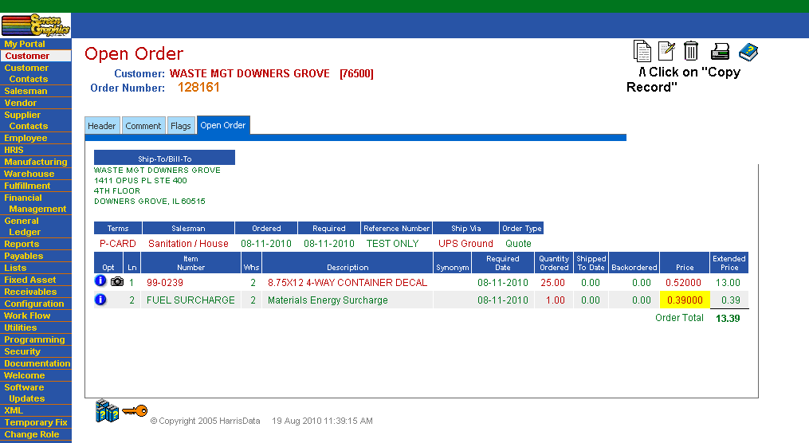

See comments below. Click Check Mark In COPY TO tab to complete new order.
